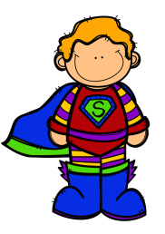
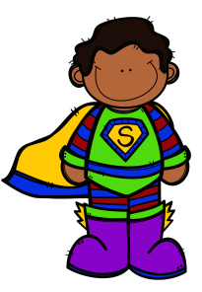
Name: _____________________
Cut out the words. Glue them in alphabetical order.
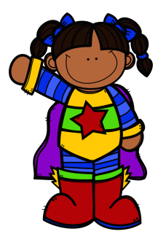
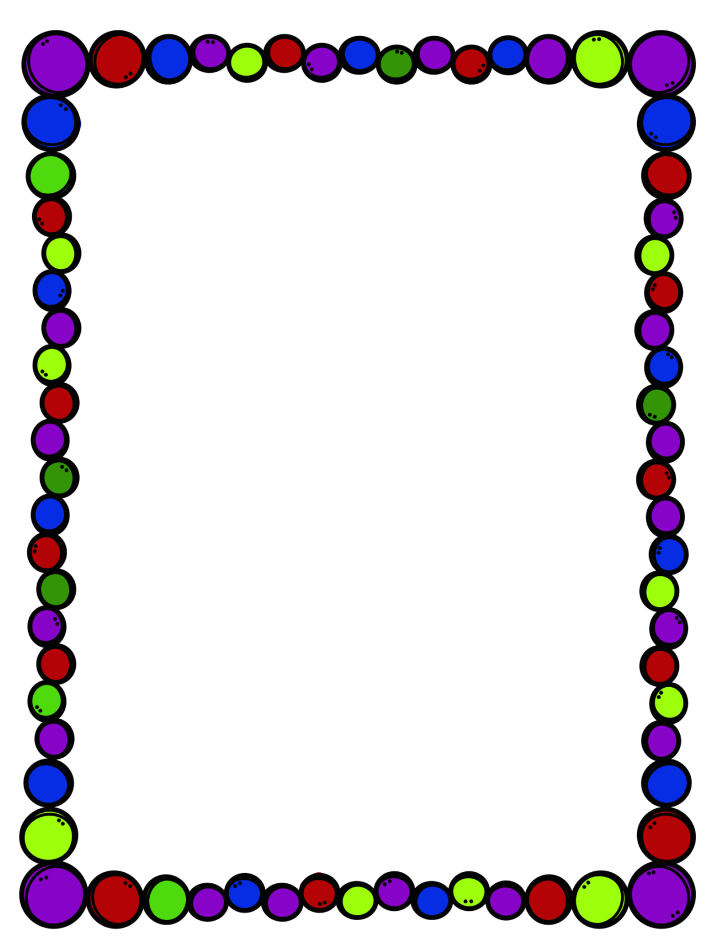
REMEMBER: If two words start with the same letter, look at the second letter to determine their order.
hero
super
cape
mask
save
brave
boots
help
strong
fly

1.
2.
3.
4.
5.
6.
7.
8.
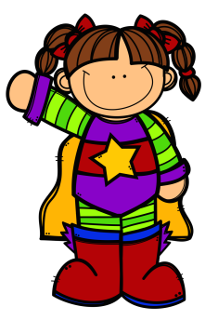
9.
10.

