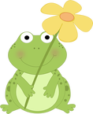
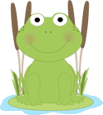
All About Me!
(a special computer lab project using Microsoft Word)
Name:
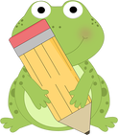
Age:

Grade:

Birthday:

My Favorite Things!
My favorite food is
My favorite color is
My two favorite animals are
My favorite sport is

