Name:

**Big B, little b,**

[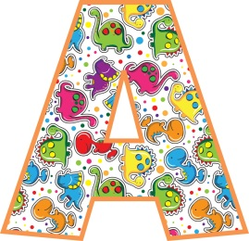](http://pixshark.com/letter-a-images.htm)[](http://www.inthehoopdesigns.com/x-cart/product.php?productid=16318)[](http://www.google.com/url?sa=i&rct=j&q=&esrc=s&frm=1&source=images&cd=&cad=rja&uact=8&ved=0CAcQjRw&url=http%3A%2F%2Fetc.usf.edu%2Fpresentations%2Fextras%2Fletters%2Fvarsity_letters%2F39%2F34%2Findex.html&ei=JcV1Ve3_I-zlsATHs4HIAg&bvm=bv.95039771,d.cWc&psig=AFQjCNHj-coKEMbWixLmePzs98XeGhb5mA&ust=1433867924953173)**[](http://www.google.com/url?sa=i&rct=j&q=&esrc=s&frm=1&source=images&cd=&cad=rja&uact=8&ved=0CAcQjRw&url=http%3A%2F%2Fetc.usf.edu%2Fpresentations%2Fextras%2Fletters%2Fvarsity_letters%2F39%2F13%2Findex.html&ei=JcV1Ve3_I-zlsATHs4HIAg&bvm=bv.95039771,d.cWc&psig=AFQjCNHj-coKEMbWixLmePzs98XeGhb5mA&ust=1433867924953173)**[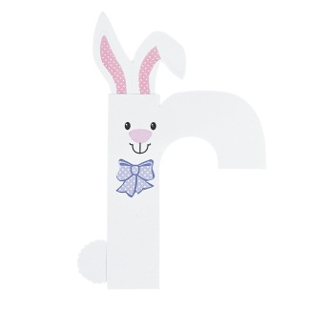](http://www.google.com/url?sa=i&rct=j&q=&esrc=s&frm=1&source=images&cd=&cad=rja&uact=8&ved=0CAcQjRw&url=http%3A%2F%2Fwww.orientaltrading.com%2Fr-is-for-rabbit-lowercase-letter-r-craft-kit-a2-13603447.fltr&ei=5cR1VerEIeTjsATE14DwAQ&bvm=bv.95039771,d.cWc&psig=AFQjCNGBY-X_PisFBVfzv7JHkw4SNK2ijA&ust=1433867859608719)**[](http://www.google.com/url?sa=i&rct=j&q=&esrc=s&frm=1&source=images&cd=&cad=rja&uact=8&ved=0CAcQjRw&url=http%3A%2F%2Fpixshark.com%2Flowercase-letter-b.htm&ei=vMR1VYTyM8bHsQTCroCADQ&bvm=bv.95039771,d.cWc&psig=AFQjCNHAlfhzqFX5gdUbTVDEhX25QU6gzw&ust=1433867763708122)[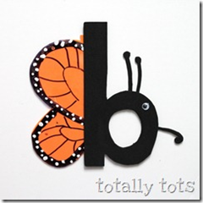](http://www.google.com/url?sa=i&rct=j&q=&esrc=s&frm=1&source=images&cd=&cad=rja&uact=8&ved=0CAcQjRw&url=http%3A%2F%2Fwww.homeschoolcreations.net%2F2010%2F07%2Fpreschool-corner-lowercase-letter%2F&ei=e8R1VbSpBYu1sQTpy4GoDw&bvm=bv.95039771,d.cWc&psig=AFQjCNHAlfhzqFX5gdUbTVDEhX25QU6gzw&ust=1433867763708122)[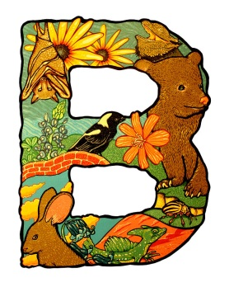](http://www.google.com/url?sa=i&rct=j&q=&esrc=s&frm=1&source=images&cd=&cad=rja&uact=8&ved=0CAcQjRw&url=http%3A%2F%2Freadik.ru%2Fstr1_7_1_3.php&ei=R8R1Vd63NtPIsQTF34PQBw&bvm=bv.95039771,d.cWc&psig=AFQjCNFScTmbwXXkKSvDDuwf7CROZIJoqQ&ust=1433867614464319)[](http://www.google.com/url?sa=i&rct=j&q=&esrc=s&frm=1&source=images&cd=&cad=rja&uact=8&ved=0CAcQjRw&url=http%3A%2F%2Fgeekgirllife.com%2Fsketch-letter-b%2F&ei=R8R1Vd63NtPIsQTF34PQBw&bvm=bv.95039771,d.cWc&psig=AFQjCNFScTmbwXXkKSvDDuwf7CROZIJoqQ&ust=1433867614464319)**[](http://www.google.com/url?sa=i&rct=j&q=&esrc=s&frm=1&source=images&cd=&cad=rja&uact=8&ved=0CAcQjRw&url=http%3A%2F%2Fetc.usf.edu%2Fpresentations%2Fextras%2Fletters%2Fvarsity_letters%2F36%2F14%2Findex.html&ei=GcR1VdUp8bWxBNrJg3g&bvm=bv.95039771,d.cWc&psig=AFQjCNFScTmbwXXkKSvDDuwf7CROZIJoqQ&ust=1433867614464319)**can you find the B’s?**