Name:
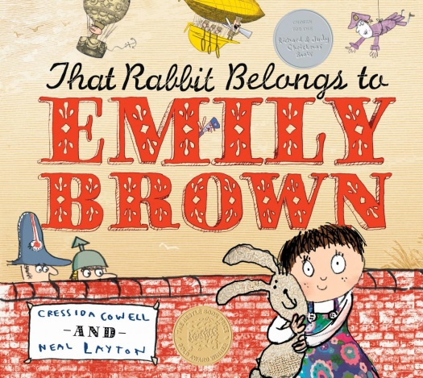
Emily Brown’s rabbit is very special to her. She played with him every day and they went on special adventures together.

Pick one of your favorite toys and tell why it is so special. What things do you like to do together?
------------------------------------------------------------
My favorite toy is

