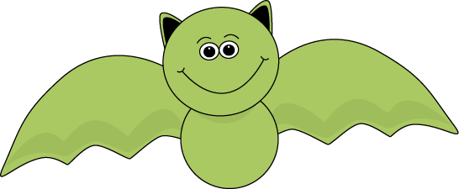
Name: _____________________
Cut out the words.
Glue them in alphabetical order.
1.
bat | mammal
night | echo
black | wings
fly | fast
cave | brown
2.
3.
4.
5.
6.
7.
8.
9.
10.

