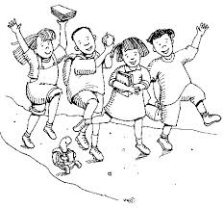
Name: _____________________
Cut out the words.
Glue them in alphabetical order.
1.
Eric | Emily
Emma | Elizabeth
Elijah | Dena
Dylan | Drew
Colin | Charlotte
2.
3.
4.
5.
6.
7.
8.
9.
10.

