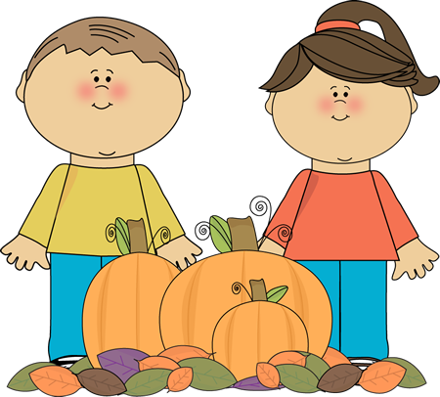
Name: _____________________
Cut out the words.
Glue them in alphabetical order.
1.
leaves | autumn
October | November
orange | red
yellow | rake
chipmunk | squirrel
2.
3.
4.
5.
6.
7.
8.
9.
10.

