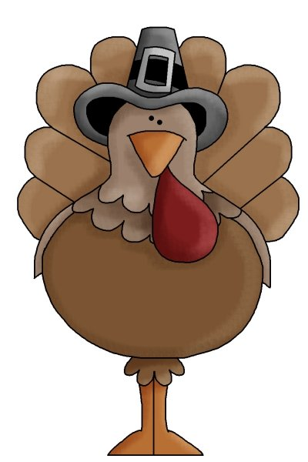
Name: _____________________
Cut out the words.
Glue them in alphabetical order.
1.
turkey | gobble
Pilgrim | Indian
friends | family
together | cook
celebrate | holiday
2.
3.
4.
5.
6.
7.
8.
9.
10.

