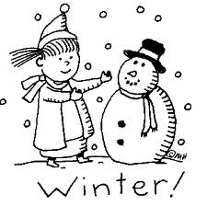
Name: _____________________
Cut out the words.
Glue them in alphabetical order.
1.
winter | build
snow | boots
sled | hat
gloves | scarf
mittens | coat
2.
3.
4.
5.
6.
7.
8.
9.
10.

