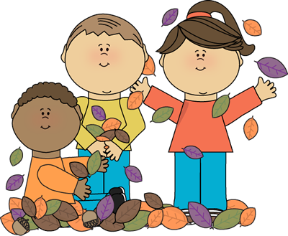
Name: _____________________
Cut out the words.
Glue them in alphabetical order.
1.
acorn | apple
spider | scarecrow
cider | pumpkin
corn | pie
leaves | bat
2.
3.
4.
5.
6.
7.
8.
9.
10.

