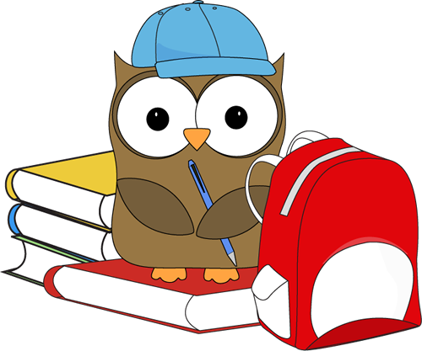
Name: _____________________
Cut out the words.
Glue them in alphabetical order.
1.
owl | hoot
feather | hat
wings | bird
book | listen
learn | friend
2.
3.
4.
5.
6.
7.
8.
9.
10.

