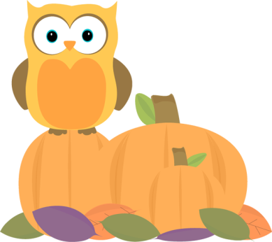
Name: _____________________
Cut out the words. Glue them in the correct box.
There should be 6 words in each box.
Common Nouns | Proper Nouns
September | candy | owl | October
autumn | Kelsey | Isom | Tuesday
Colin | spider | leaf | pumpkin

