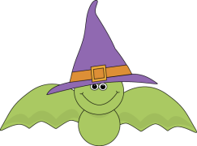
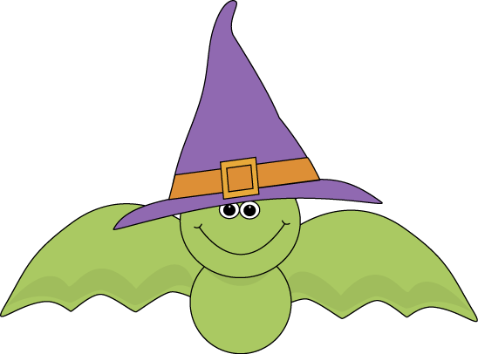
Name: _____________________
Cut out the words. Glue them in the correct box.
There should be 6 words in each box.
Singular Nouns | Plural Nouns
bat | bats | treats | treats
foxes | fox | pumpkins | children
child | pumpkin | leaf | leaves

