iPad Rules
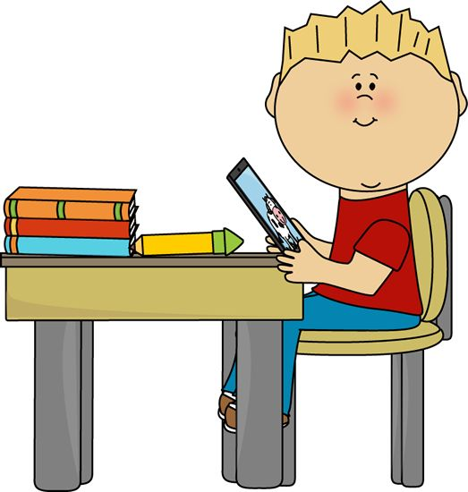
Be Safe
*Use two hands.
*Sit while you use it.
*Return it when finished.

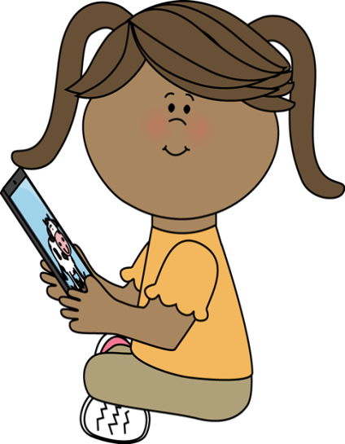
Be Responsible
*Use the appropriate apps.
*Have clean hands.
*Speak with the teacher if you have a problem.
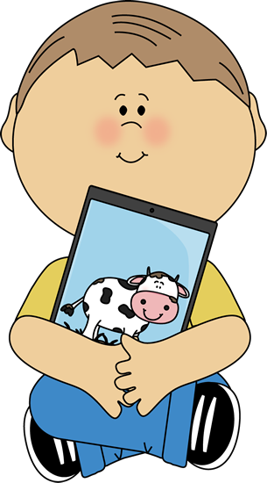
Be Respectful
*Monitor your time.
*Let your teacher know when the battery is less than 50%.
*Use gentle hands.

