Penguin Synonyms & Antonyms
(a special computer lab project using Microsoft Word)
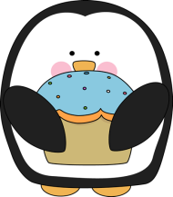
Write a synonym for each word.
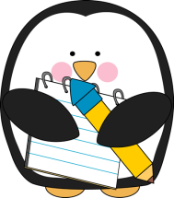
happy =
mad=
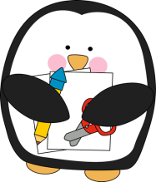
dish=
present=
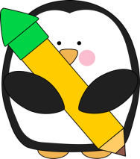
tired=
infant

Write an antonym for each word.
left=
day=
down=
sad=
hot=
worst=

