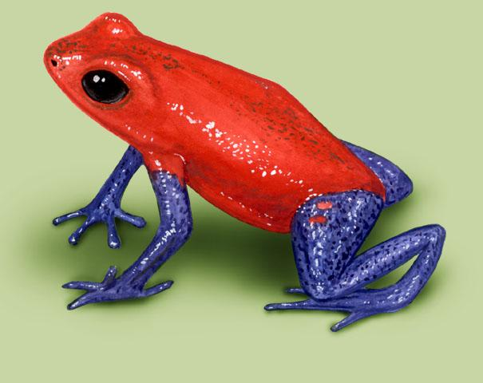Name: ________________________________ Date: __________

Miss Ploutz’s class went to a rainforest for summer vacation. They found lots of poison dart frogs. Use the chart below to answer the questions.

**The Number of Frogs Each Student Saw**

|  |  |  |
| --- | --- | --- |
|  | Strawberry Poison Dart Frog | Blue Poison Dart Frog |
| Dylan | 0 | 14 |
| Emma | 6 | 3 |
| Autumn | 1 | 15 |
| Carter | 4 | 6 |

Who saw the most Blue Poison Dart Frogs? _______________

Who saw the fewest Strawberry Poison Dart Frogs? _______________

How many frogs did Emma see in all? ________________

Who saw more frogs, the boys or the girls? The __________ saw more frogs.

If Dylan went back into the rainforest, what kind of frog would he probably find? Why?

Dylan would most likely find a ___________ Poison Dart Frog because______

________________________________________________________________

_____________________________________________________________