Name: ________________________________ Date: __________
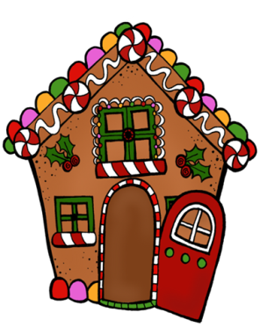
Ava and Anna made gingerbread houses. They had 16 extra pieces of candy when they were done. They ate half of the extra candy and gave the rest to Mrs. Wooton.
How many pieces of candy did they each get?
Answer: ______________
Show your work.

Explain how you solved this problem.
______________________________________________________________________________________________________________________________________________________________________________________________________________________________________________________________________________________________________________________________
Challenge: If 4 of the candies were peppermints and the rest were chocolate, how many pieces of chocolate were there?

