Name: _____________________
Cut out the words. Glue them next to their synonyms.
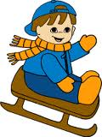
REMEMBER: Synonyms= 2 words that mean the same
1. glad =
big
tiny
chilly
angry
dish
tidy
toasty
happy
quick
scream
2. warm =
3. plate =
4. mad =
5. large =
6. small =
7. shout =
8. cold =
9. clean =
10. fast =

